

CSA0501-DATABASE MANAGEMENT SYSTEMS

LAB EXPERIMENTS DATE: 07/08/2026

EXPERIMENT 16– HIGH LEVEL PROGRAMMING EXTENSIONS – PROCEDURES
AIM: To implement procedures using programs in MySQL.

PROCEDURE:
- Select the pet_management database.
- Create a stored procedure using the CREATE PROCEDURE command.
- Use DELIMITER to define the procedure containing multiple SQL statements.
- Execute the procedure using the CALL command.
- Create a parameterized procedure to process pet details.
- Execute the parameterized procedure by passing required values.
- Verify the output successfully.

PROGRAM:

Display all records from pet_details:

DELIMITER //

CREATE PROCEDURE get_all_pets()

BEGIN

SELECT * FROM pet_details;

END //

DELIMITER ;

OUTPUT:

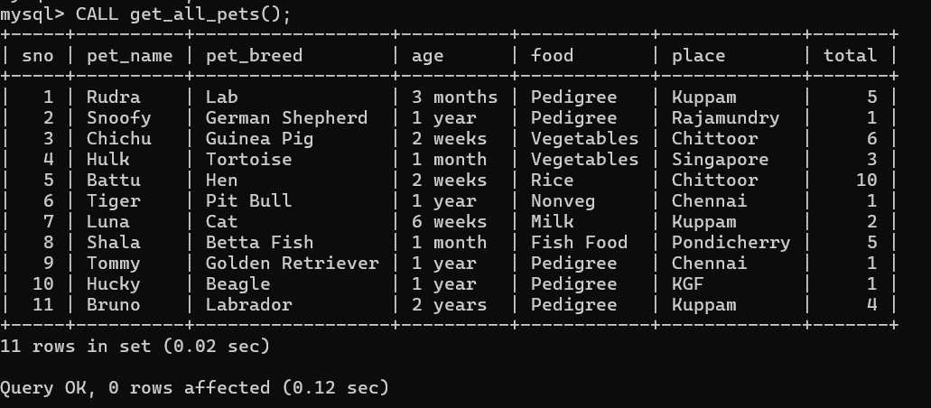
- Parameterized Procedure:
Here we pass the pet name and get its complete details.
DELIMITER //
CREATE PROCEDURE get_pet_details(IN p_pet_name VARCHAR(30))
BEGIN
SELECT *
FROM pet_details
WHERE pet_name = p_pet_name;
END //
DELIMITER ;

OUTPUT:

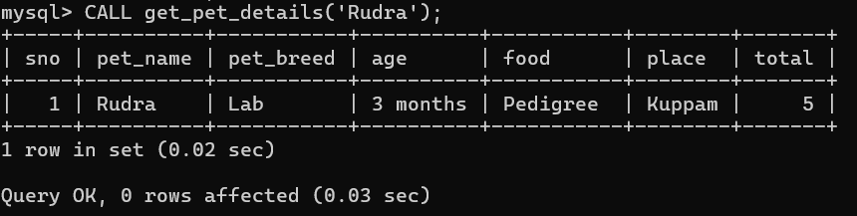

RESULT:Thus the high level proceduresprogramsare executed successfully.

